Paper title for the conference
A.B. AuthorOne¹ , C.D. AuthorTwo² , E.F. AuthorThree¹, G.H. AuthorFour³
¹Department of Civil and Environmental Engineering, University of New Hampshire, Durham, USA
²Geotechnical Consulting Group, San Diego, USA
³Institute/Company/University, City, Country

ABSTRACT: This template illustrates the format that must be used in the preparation of full papers for the UNSAT2027 workshop. Papers are to be submitted in English, based on the originally submitted abstract. All manuscripts must be prepared electronically and submitted in accordance with the following instructions using the online submission platform provided on the conference web site. Do not exceed 200 words for abstract. Abstracts are text-only, so please do not include figure numbers, equation numbers or table numbers, nor any references. The abstract must be a single column and fully justified. The abstract is set in Times New Roman 10pt font. Lorem ipsum dolor sit amet, ne meis aeterno necessitatibus mei, te eum quando cetero nostr um, per justo utroque omittam eu. Modo assentior has in, utamur aliquip admodum duo in, sit natum mediocrem at. Aliquid definiebas no has, nam justo malis simul at, ridens invidunt duo eu. Eam id dolore verear delicata, vis phaedrum deseruisse adipiscing ut. Lorem ipsum dolor sit amet, ne meis aeterno necessitatibus mei, te eum quando cetero nostr um, per justo utroque omittam eu. Modo assentior has in, utamur aliquip admodum duo in, sit natum mediocrem at.

Keywords: Keywords should use Times New Roman 9 pt. font; separated by semicolon; Maximum 5 words

guidelines
Please read this text, saved in the standard Microsoft Word .docx format, before you start preparing your paper for the proceedings of UNSAT2027. The purpose of these guidelines is not only to clarify the paper layout, but also to emphasise the imperative of everyone complying exactly with the instructions and using the official format available on the conference website, in order for the proceedings to be of the highest quality and to be published online in time for the conference. Your paper will not be accepted for publication if it does not follow the instructions below. Papers are limited to 6 pages of text and figures, with the main text in Times New Roman 11pt font and single spaced. No contributions with an odd number of pages are permitted. Please do not change the page size or format of the submitted document.

Publication and submission
Paper submissions must be an electronic copy of a Microsoft Word Document, as well as a PDF file of the paper. The proceedings will be published in digital format only. Submitted papers shall not be more than 8 Mb in size. Papers will be published in free and open access in the ISSMGE Online Library and indexed with their own individual DOI number. Papers will also be available online at the conference website.
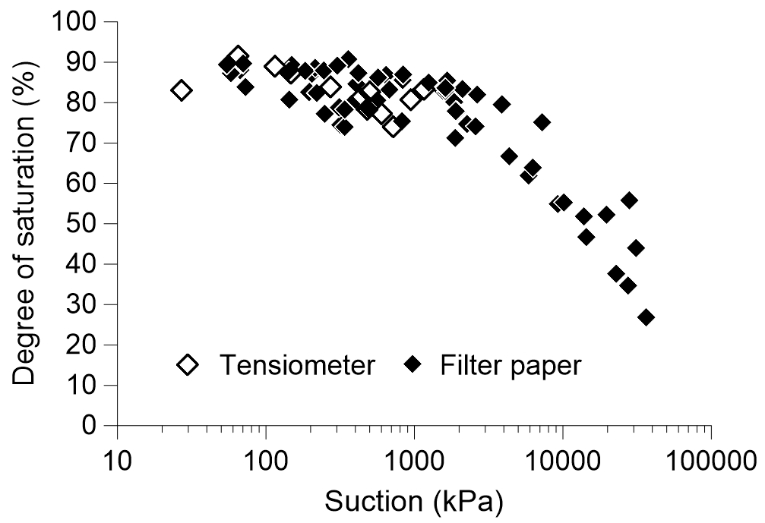
Figure 1. Suction measurements (10pt font)

Language
The paper shall be written in UK English and spell-checked before submission. The Concise Oxford Dictionary, Chambers Technical Dictionary and Oxford Dictionary for Scientific Writers and Editors can be used as guides. Avoid single sentence paragraphs.

Page formatting and layout
The paper must be in double column format, 8.6cm wide with central separation of 0.8 cm. The left and right margins of the page are set at 1.5 cm. Headers and footers are set different for the first page and for odd and even pages. You must not alter the content and format of headers and footers.
All paragraphs must be fully justified. The first paragraph in a section is not indented, while the first line in subsequent paragraphs must be indented by 0.4 cm. This template has been set up with the required page layout. You must not alter any settings.

File name
The file name on submission must be specified as follows:
UNSAT2027-aaa_xxxxx.docx /.doc
UNSAT2027-aaa_xxxxx.pdf
with the following meaning:
aaa the abstract ID number
xxx the first author’s last name

examples: UNSAT2027-5_surname1.docx
UNSAT2027-317_surname2.pdf

Text Format
Please note that the layout of all sections that appear after the abstract has to be double column. This means that only the double column layout is acceptable for publication. The two columns of text on the last page of each paper must be balanced (that is, adjusted to have the same vertical extent; use the column break to achieve this).

Type area and page size
Do not amend the margin settings or page dimension within the template. These are as follows:
297 x 210 mm page size:
Top 2.0 cm
Bottom 2.0 cm
Left 1.5 cm
Right 1.5 cm
Do not change headers and footers. Only add the title of your paper where indicated in the header on odd pages (3, 5) and topic (theme) of your paper in the header on even pages (2, 4, 6), for example: Experimental laboratory characterisation of the multiscale Bio-Hydro-Chemo-Mechanical behaviour of rooted soils.

Structure
Please adhere to the following order of presentation: Title, Author(s), Affiliation(s), Abstract, Main text, Conclusion, Acknowledgement, References.
The title should be written as a sentence, with NO capitalisation of words, apart from the first word. No full stop (“.”) at the end of the title.
For example: Suction measurements in vegetated soils (Not: Suction Measurements In Vegetated Soils).

Author(s)
Author should start with the Initial(s) and then the Family name. For example: K. Terzaghi, A. Einstein, F.S. Fitzgerald

Titles
Titles or occupation (such as Prof., Dr., eng. PhD etc) are NOT permitted.

Abstract
The abstract should be concise and not longer than 200 words. It must be written in a single column and fully justified.

Text
The text should be in Times New Roman 11pt font for the body of the text. The indent must be 0.4 cm. The text for the Reference section is in Times New Roman 10 pt font. Symbols should be in italics and SI (international system) units must be used throughout the manuscript. For the text, a maximum of three levels of sections and subsections is allowed. For example:
1 INTRODUCTION
1.1 Europe
1.1.1 History
1.1.2 Future
1.2 Asia
1.1.1 History
1.1.2 Future

Headings
Please do not change the type of headings applied in this template. Headings 1 and 2 should be in Times New Roman 12pt font, with heading 3 in 11pt font. Capital letters only for heading level 1. Heading levels 2 and 3 should be italic, without capitalisation of the words, apart from the first word.
It is important to reproduce the spacing of the text and headings as shown here. Text should be single spaced.

Figures and tables
Figures and tables are allowed to fill either one or two columns and must be accompanied by a caption. Colour figures and photos are accepted.
Figure caption should be in Times New Roman 10 pt, italic, placed underneath the figure. The resolution of figures must be at least 300 dpi.
Tables must follow the format below, with a caption placed above and in Times New Roman 10 pt, italic. The table content must also be Times New Roman 10pt, with headings in bold.
Figures and tables in the text should be referred to as Figure 1, Table 1 and should be numbered consecutively. Parts of a figure should be referred to as follows: Figure 1(a); Figures 1(a) and (b); Figures 1(a-c); double parentheses should be used if needed (Figure 1(a)).

Table 1. Sample (use 10 pt both in heading and table)
Heading | Sub 1.1 | Sub 1.2
Sub 2.1 | 1 | 4
Sub 2.1 | 2 | 5
Sub 2.1 | 3 | 5

If a figure or a table spans over two columns, as in the example below, then text in the left column above the figure must extend only to the top of the figure, then continue into the right column and extend only to the top of the figure. Use Section Break (Continuous) to achieve this.
The text below the figure then starts in the left column until the bottom of the page and continues into the right column from underneath the figure to the bottom of the page. Use Section Break (Continuous) to achieve this.

Equations
Samples of equations are given below, in 11pt font. Equation should be left-aligned, inserted using the built-in Word equation editor, numbered consecutively and referred to in the text by these numbers, e.g. Equation (3), Equations (1-4).
All variables should be in italic. An empty line must be placed above and below each equation. The used parameters must be described below equations.

$n^{z}=p^{'}∙K_{c}^{m}-a∙e∙K_{o}^{z}$ (1)

$B_{w}^{s}=\frac{{H_{q}^{0}+H_{q}^{∞}∙α}_{q}∙\frac{H}{B}}{1+α_{q}∙\frac{H}{B}}$ (2)

where $B$ is the Skempton parameter, etc.

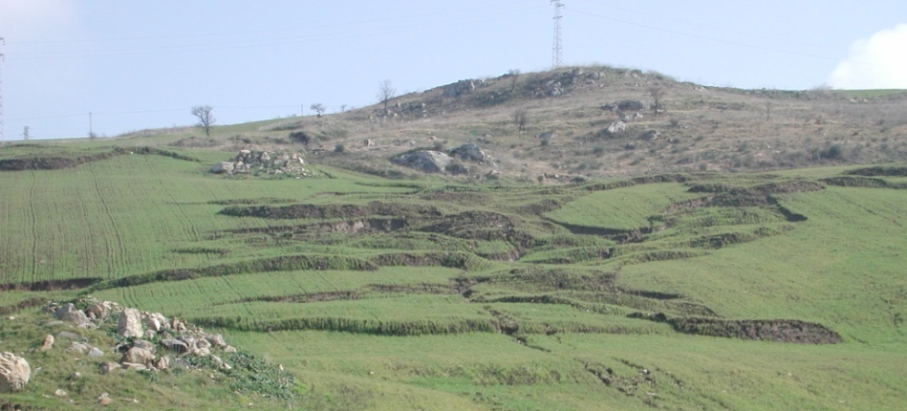
Figure 2. Figures, tables and graphs are allowed to fill either one or two columns

Citation of references in the text
Citations can be part of the text or in parentheses (e.g. ‘As stated elsewhere (Alonso, 2009) …’ or ‘As stated by Alonso (2009) …’).
Citations with multiple authors: two – identify both (e.g. (Bishop and Blight, 1963)); more than two – use et al. after the first author (e.g. (Fredlund et al., 1978)).
Multiple citations: list in alphabetical order rather than chronological (e.g. (Skempton, 2009; Bowie, 1979; Lennon, 1985)).
Different citations with the same author and year: add letters to the years (e.g. (Bishop 1969, 1971a, 1971b)).

Conclusions
Conclusions should state concisely the most important outcomes of the paper as well as the author’s views on the practical implications of the results.
If a heading of a section appears at the top of the column under the figure, as is the case in this section and Section 3.7, the spacing ‘Before’ the heading should be adjusted to 0 pt, by positioning the cursor on the heading titile, entering Paragraph in the top ribbon of your Word page, going into Spacing and entering 0 pt in the Before location.

ACKNOWLEDGEMENTS
Please place your acknowledgements section after the conclusions and before the references section. Include acknowledgements of grants, financial aid and other special assistance from collaborators.

References
References should be listed in alphabetic order and written in Times New Roman 10 pt font. Use the formatting in the examples below to distinguish between books, journal papers and conference papers.

Author, A.B. 1995. Book Title, Publisher Name, Publisher Location.
Author, A.B. 2004. Article title, Journal Title 20, 1012–1030.
Author1, A.B., Author2, C.D. 2004. Article title, Journal Title 20, 102–130.
Author, A.B. Author, C.D., Author, E.F. 2012. Article title, Journal Title 12, 12–19.
Author, A.B., Author, C.D. 2010. Paper title. Lunar Geotechnics: Proceedings, 12th IAGE Congress (Eds: Grant, H., Higgins, K.G. & Kovacevic, N.), 1002-1005. Publisher Name, Publisher Location.

